******Republic of the Philippines**

**Eulogio “Amang” Rodriguez**

**Institute of Science and Technology**

**Nagtahan, Sampaloc, Manila**

**College of Arts and Science  
Bachelor of Science in Computer Science**

**System Manual**

**Kainakap ServiceHub: An Information Platform for Kainakap Request and Services  
 BSCS – 3C**

**Mascardo,** JhonPoul O.

**Pago,** Jhondhel M.

**Alcoba,** Alvin John B.

**Solis,** Jhon Rogelio A.

**Roldan,** Ian Anthony

**Merlita Cruz Latip**

**2024**

**Statement of the Problem**

1. **PWD's Channel for Request and Inquiry.**

We observed from the previous system that has been proposed to the Kainakap Foundation that it doesn’t have an information platform to accept the requests and inquiries of the PWD about their needs.

**Cause:**

* Lack of PWD feedback

**Impact:**

* Blind operational execution due to unhandled requests and inquiries of the PWDs

1. **Identifying the needs of the PWDs in assistive equipment.**

The Kainakap Foundation takes care of their PWD's needs and treatment. Ma’am Mimi an authority in the Kainakap foundation said that they went to the home of the PWDs to assess the situation and needs of the family. The problem is due to the limited personnel for assessing the PWDs. They cannot process all of the PWD's necessities due to their disabilities.

**Cause:**

* Limited personnel to assess the situation of the PWDs

**Impact:**

* Delay to deliver assistive equipment and help for the PWD

1. **Disseminating mass information platform for event and activities awareness.**

The Kainkap don’t have an information platform to disseminate information about upcoming events and activities. This problem causes slow dissemination of information because of manual processes. There could be PWD who will not be informed in giving of assistive devices and services. They will miss the opportunity to receive aid and help with their disabilities.

**Cause:**

* lack of mass information platform to deliver news about services

**Impact:**

* · The PWD could miss the chance to receive the help of assistive devices and services arranged by kainakap.

**3.1 General Objectives**

The overarching objective of this initiative is to establish an inclusive and accessible service hub, tailored specifically to address the needs of Persons with Disabilities (PWDs) and enhance their overall well-being. Through the implementation of innovative strategies and technologies, our aim is to achieve the following:

**3.2 Specific Objectives**

* Facilitate Communication Channel: Develop and implement a user-friendly channel for PWDs to submit requests and inquiries, ensuring accessibility and inclusivity in all communication processes.
* Optimize Assistive Equipment Provision: Conduct thorough assessments to accurately identify the assistive equipment needs of PWDs, and establish efficient mechanisms for procurement, distribution, and maintenance of such equipment.
* Promote Community Engagement: Utilize a mass information platform to disseminate awareness about events, activities, and resources relevant to PWDs, boosting community engagement and participation.

**USER/CLIENT SIDE**

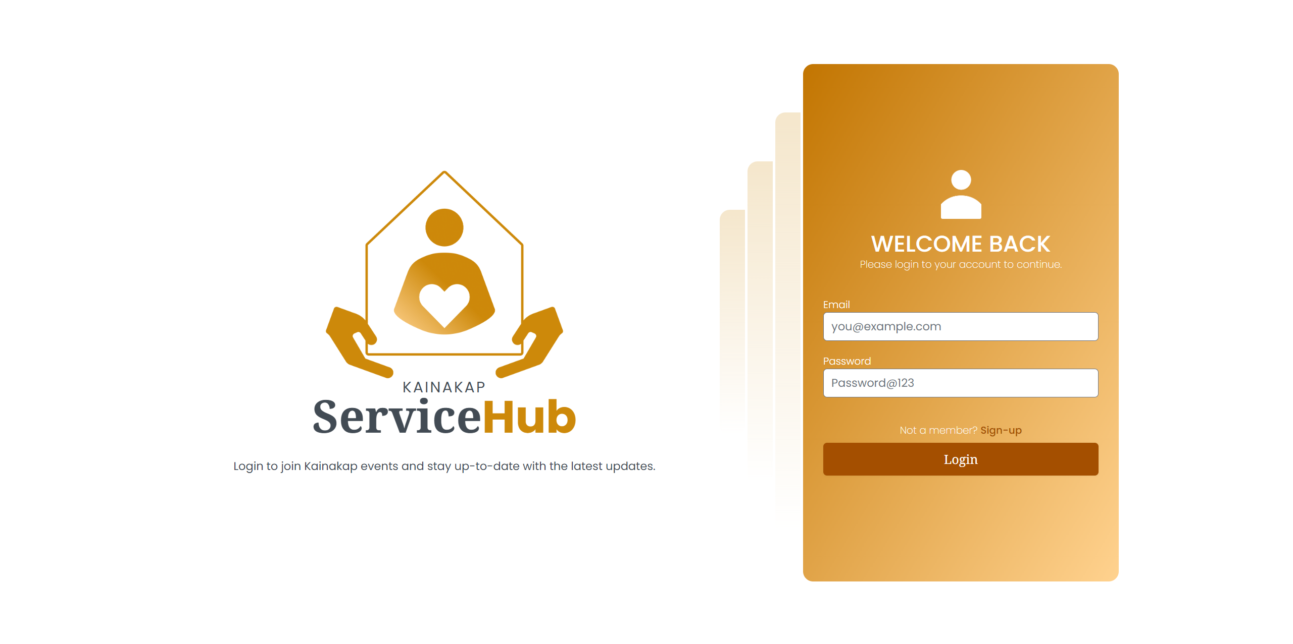 **Figure 1 :** Sign In Page

* This image displays the sign-in page where users/clients are required to enter their credentials to access the system. It includes fields for the username and password, along with a 'Sign In' button.

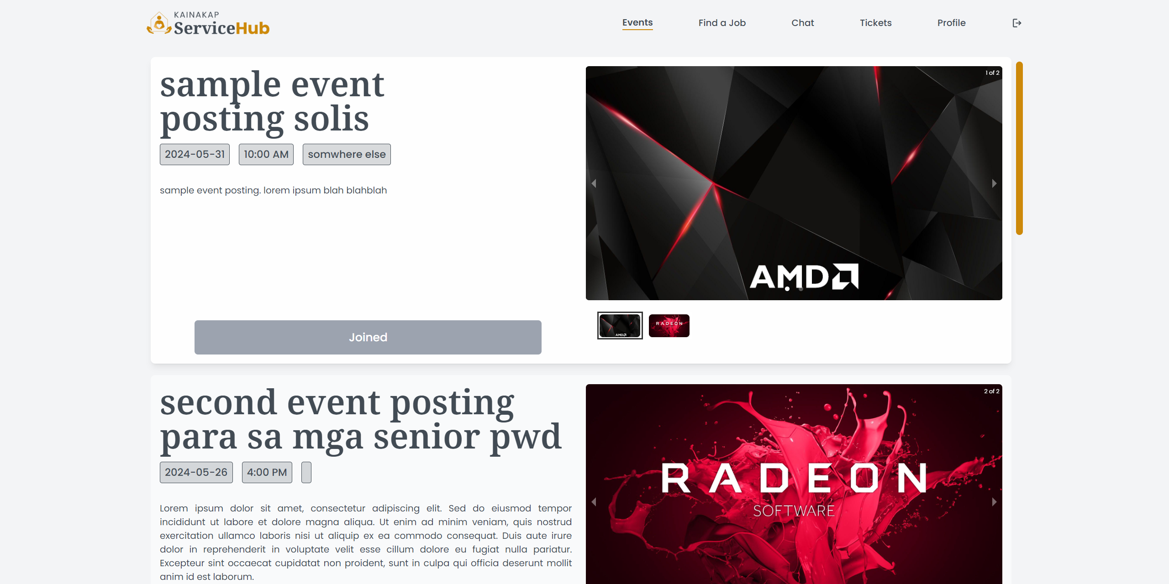 **Figure 2 :** Event

* This image presents the announcements page where users/clients can view all the announcements posted by the admins. Each announcement includes a image content, title, date, and the announcement content.

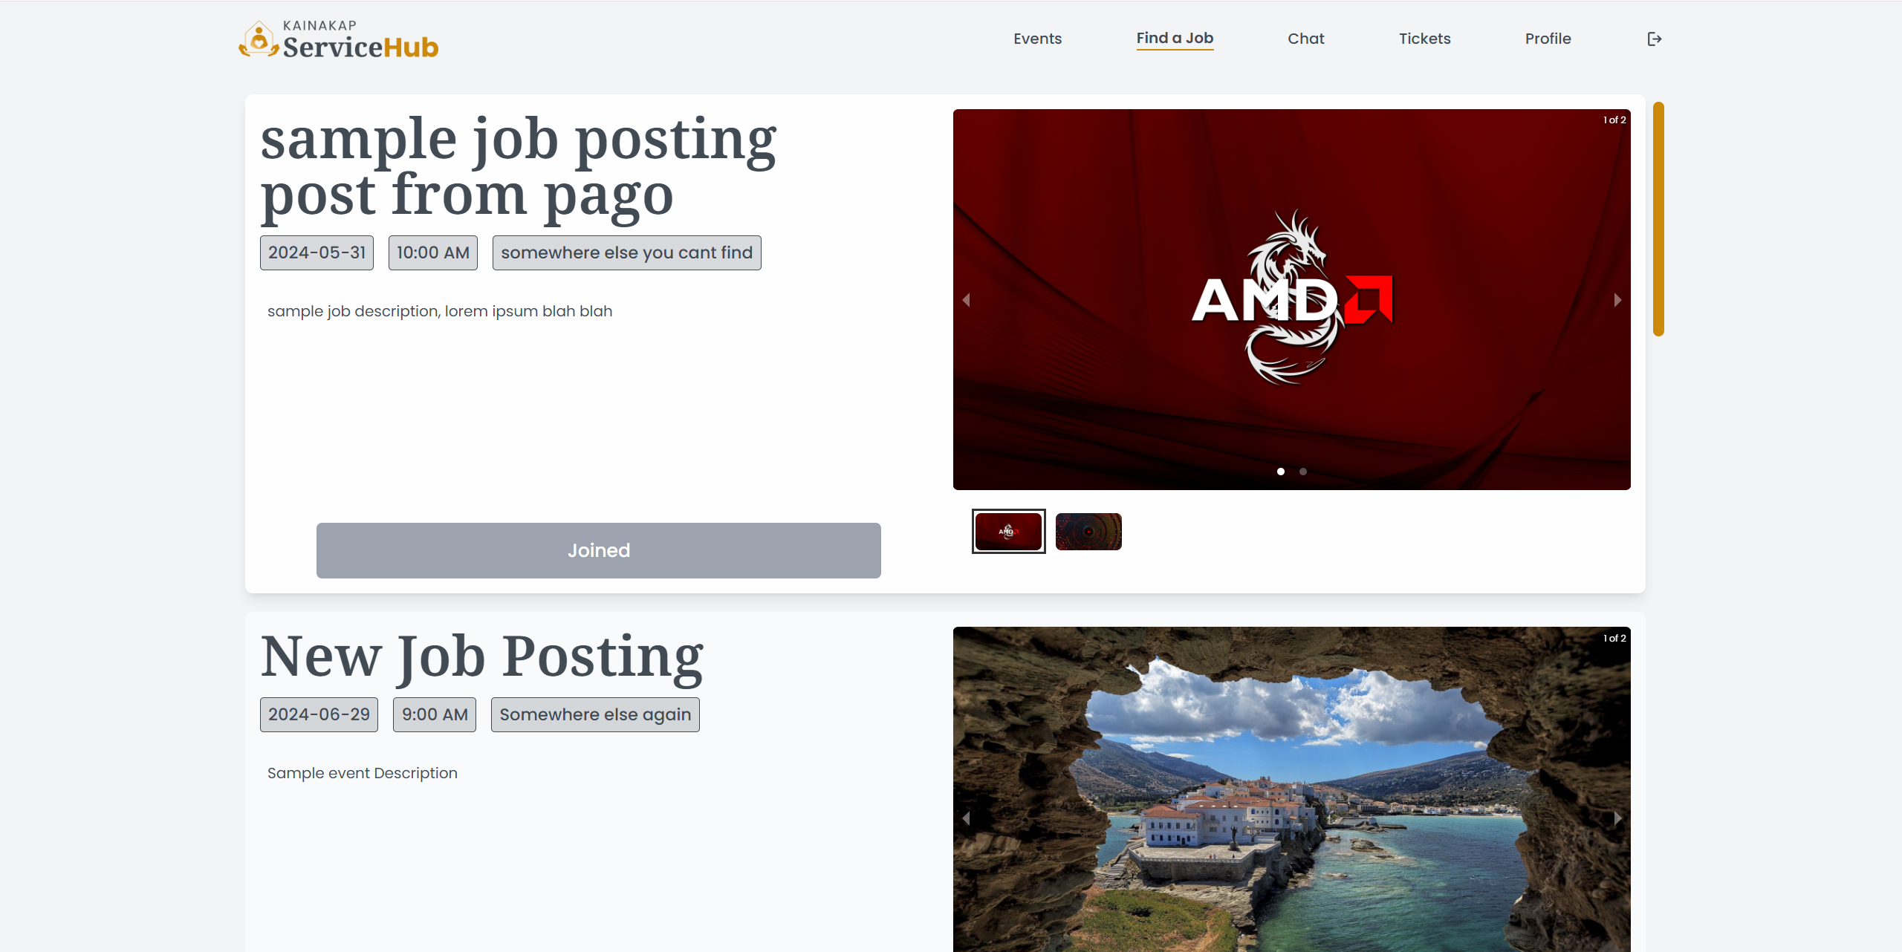 **Figure 3 :** Find Job

* This image display the announcements for Job where users/clients can view all the Jobs they qualify base on their disability posted by the admins. Each Job announcement includes a criteria if they are eligible to apply.

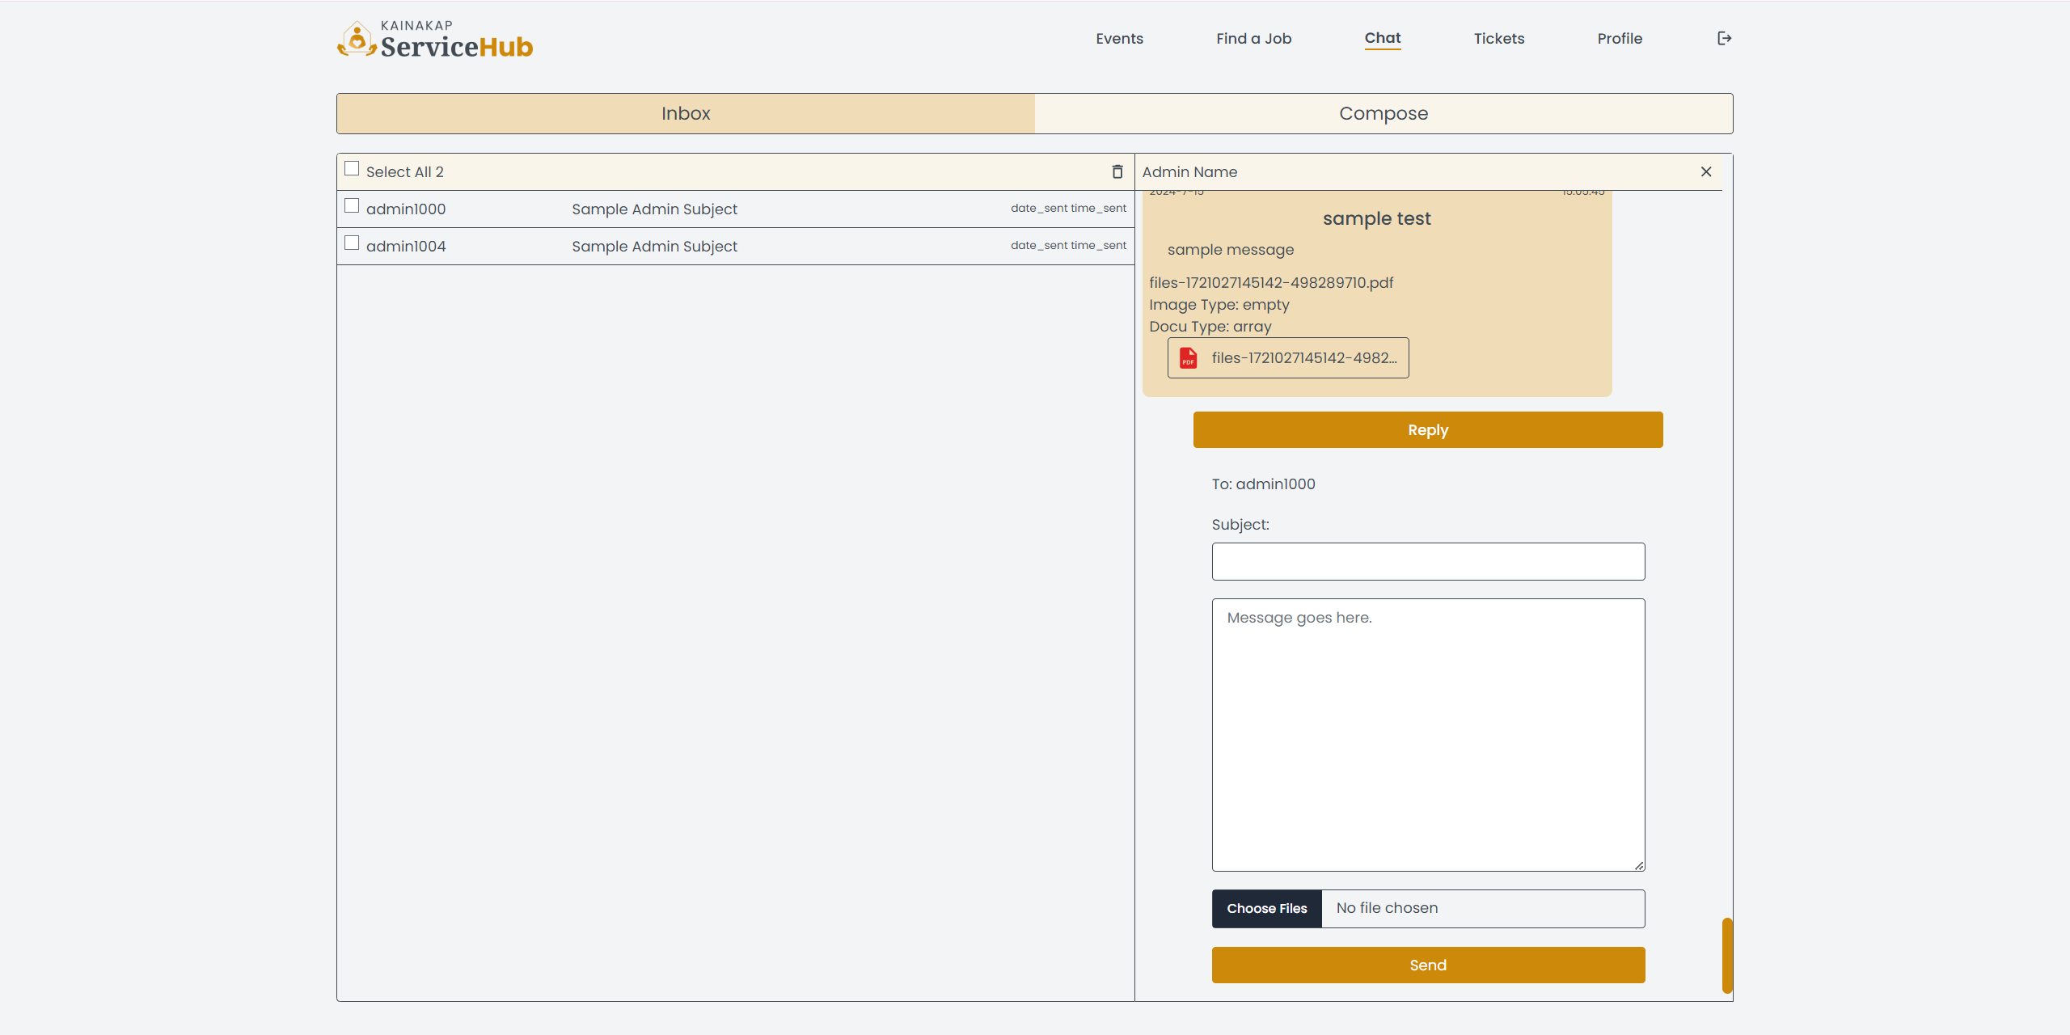 **Figure 4 :** Chat

* The Chat page allows users to send their concerns or issues directly to the admin. It includes fields for entering the subject, their inquiries, requests, and a 'Send' button to send the message.

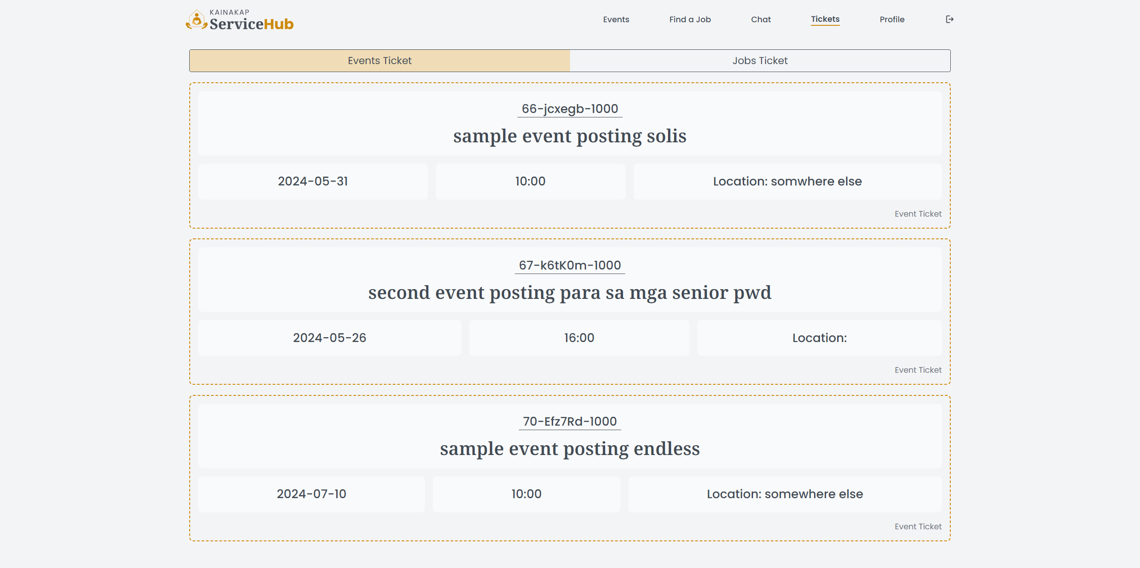**Figure 5.1 :** Event Tickets

* This image displays the unique tickets for events, allowing users/clients to see the events they have joined.

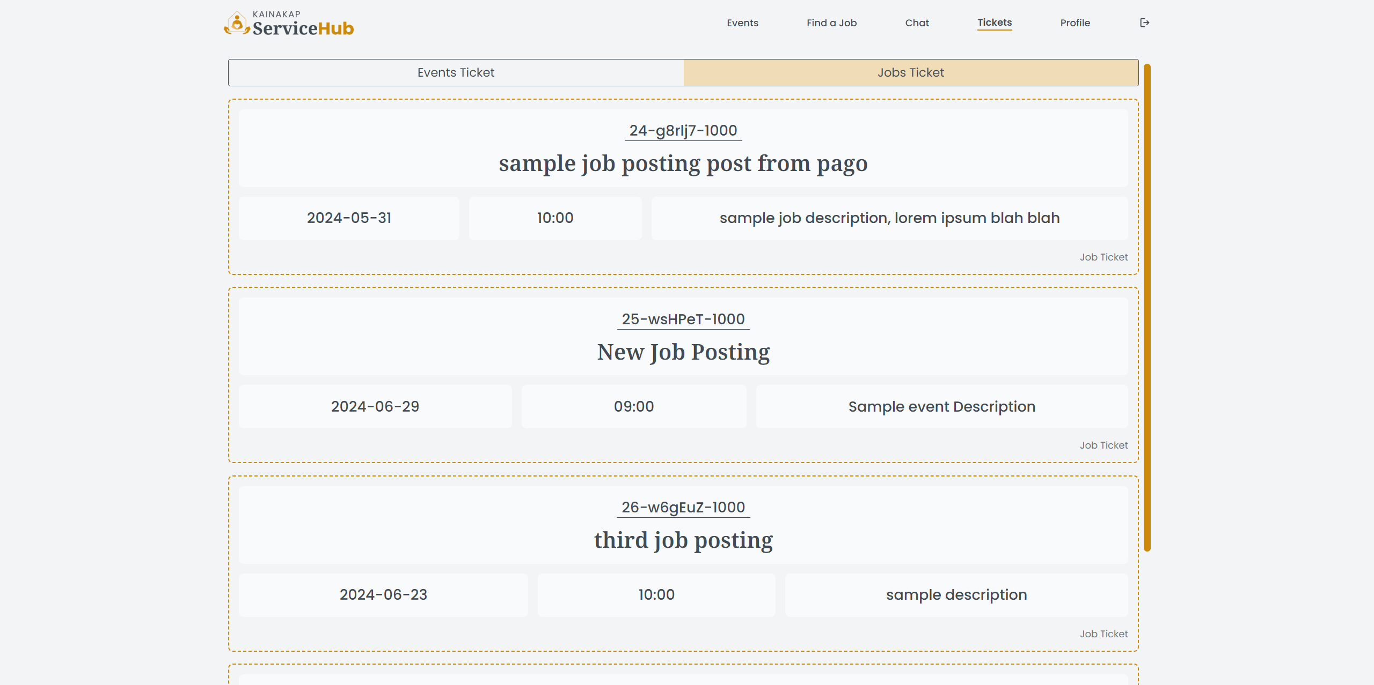

**Figure 5.2 :** Job Tickets

* This image displays the unique tickets for jobs, allowing users/clients to see the job they have joined.

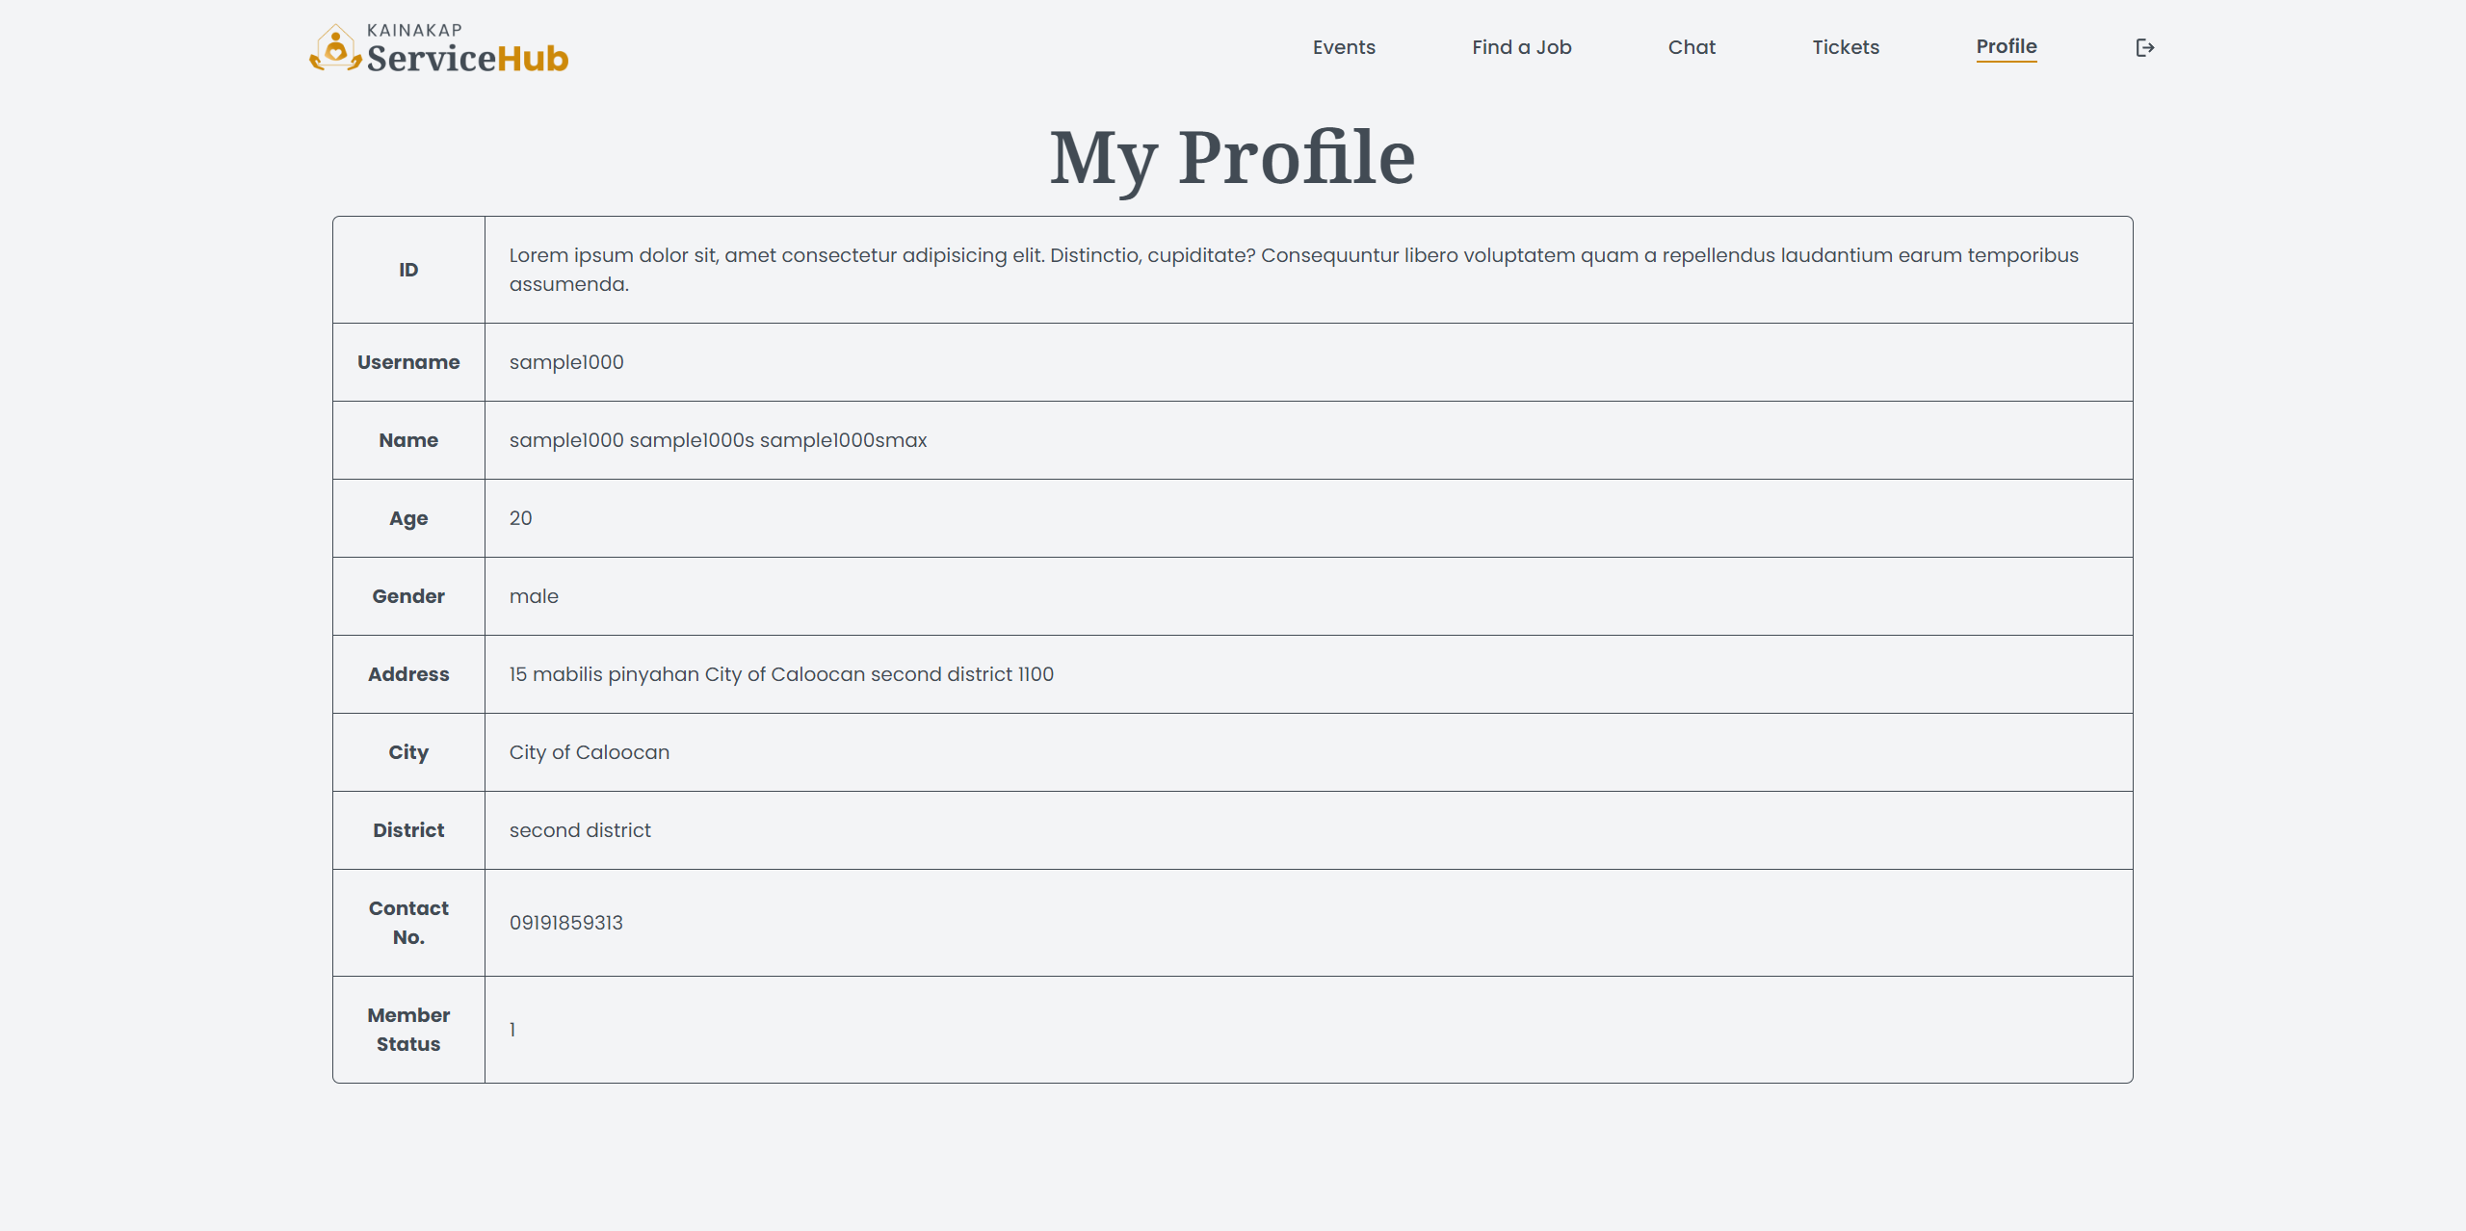

**Figure 6 :** Profile

* This image displays the unique ID, Username, Name, Age, Gender, Address, Contact Number, and Member Status of the user/client if they are active or not.

**ADMIN SIDE**

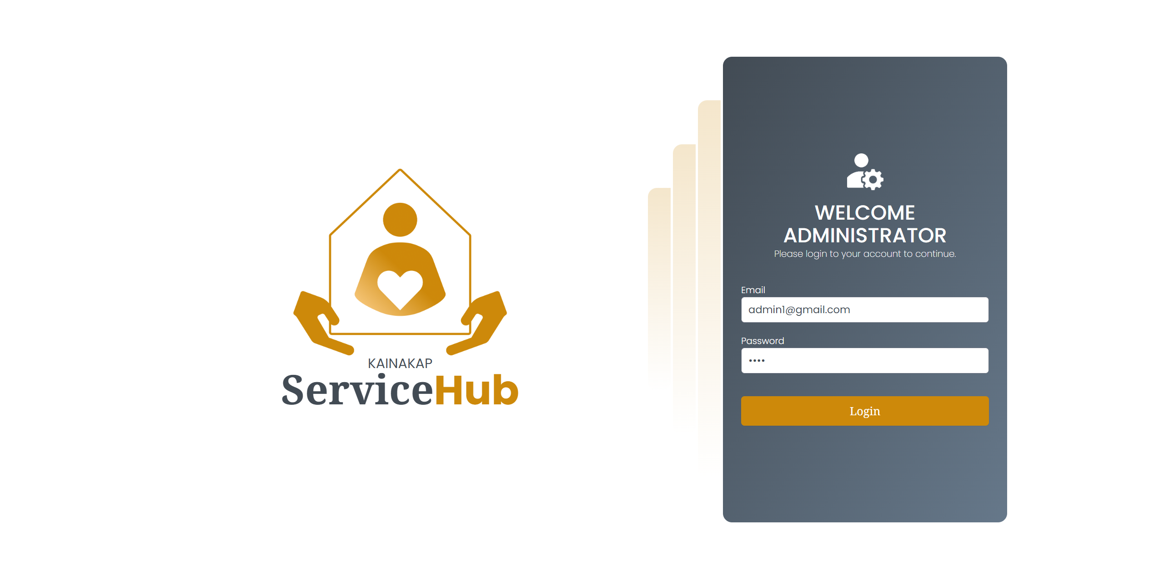 **Figure 1 :** Sign In Page

* This image displays the sign-in page where Admin are required to enter their credentials to access the system. It includes fields for the username and password, along with a 'Sign In' button.

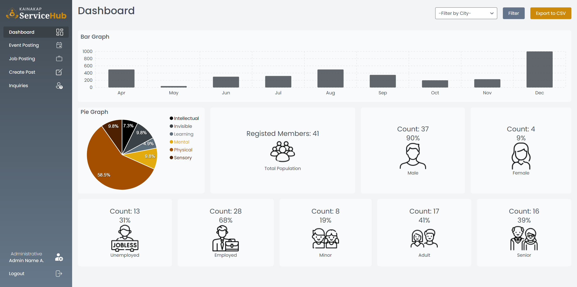

**Figure 2 :** Dashboard

* The admin dashboard shows graphs about persons with disabilities, including the percentage and count of registered members, males, females, unemployed, employed, minors, adults, and seniors. Users can also filter the data by city and download it as a CSV file.

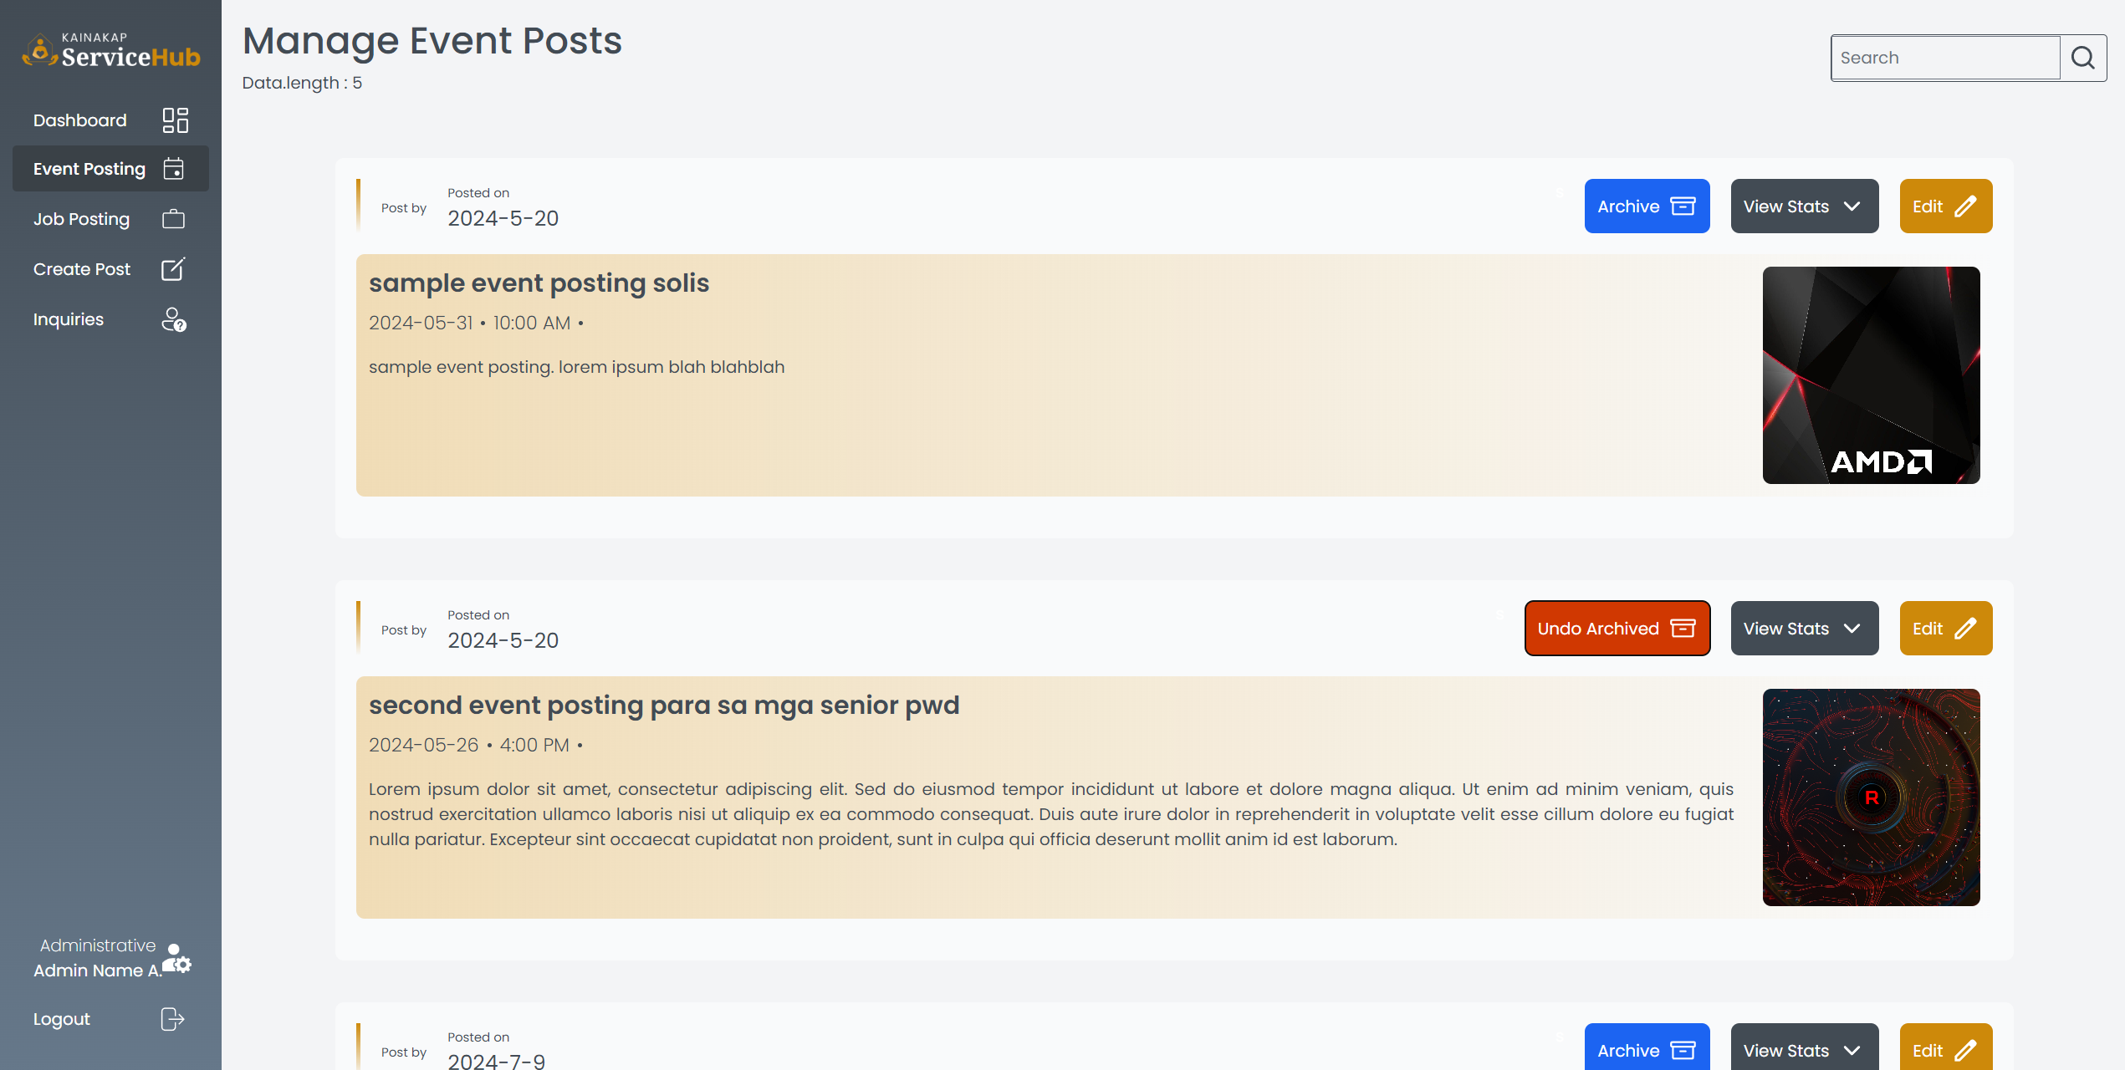

**Figure 3 :** Event Posting

* This page allows admins to press the button archive or undo archive posted events, view statistics on who joined the event, and edit the posted event.

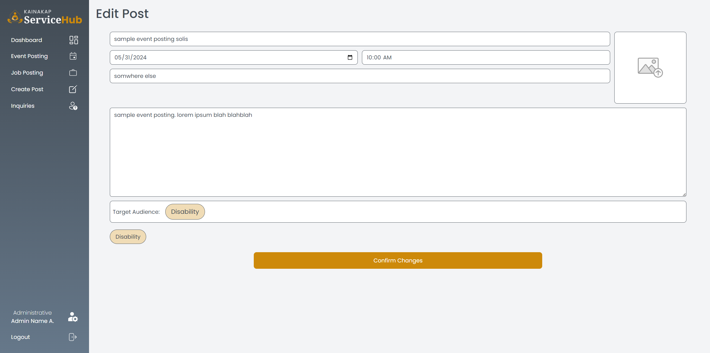 **Figure 3.1 :** Edit Post

* This page allows admins to edit the title of the event, time and date of the event, the place where the event will take place, the context of the event, and the target user/client eligible to join the event.

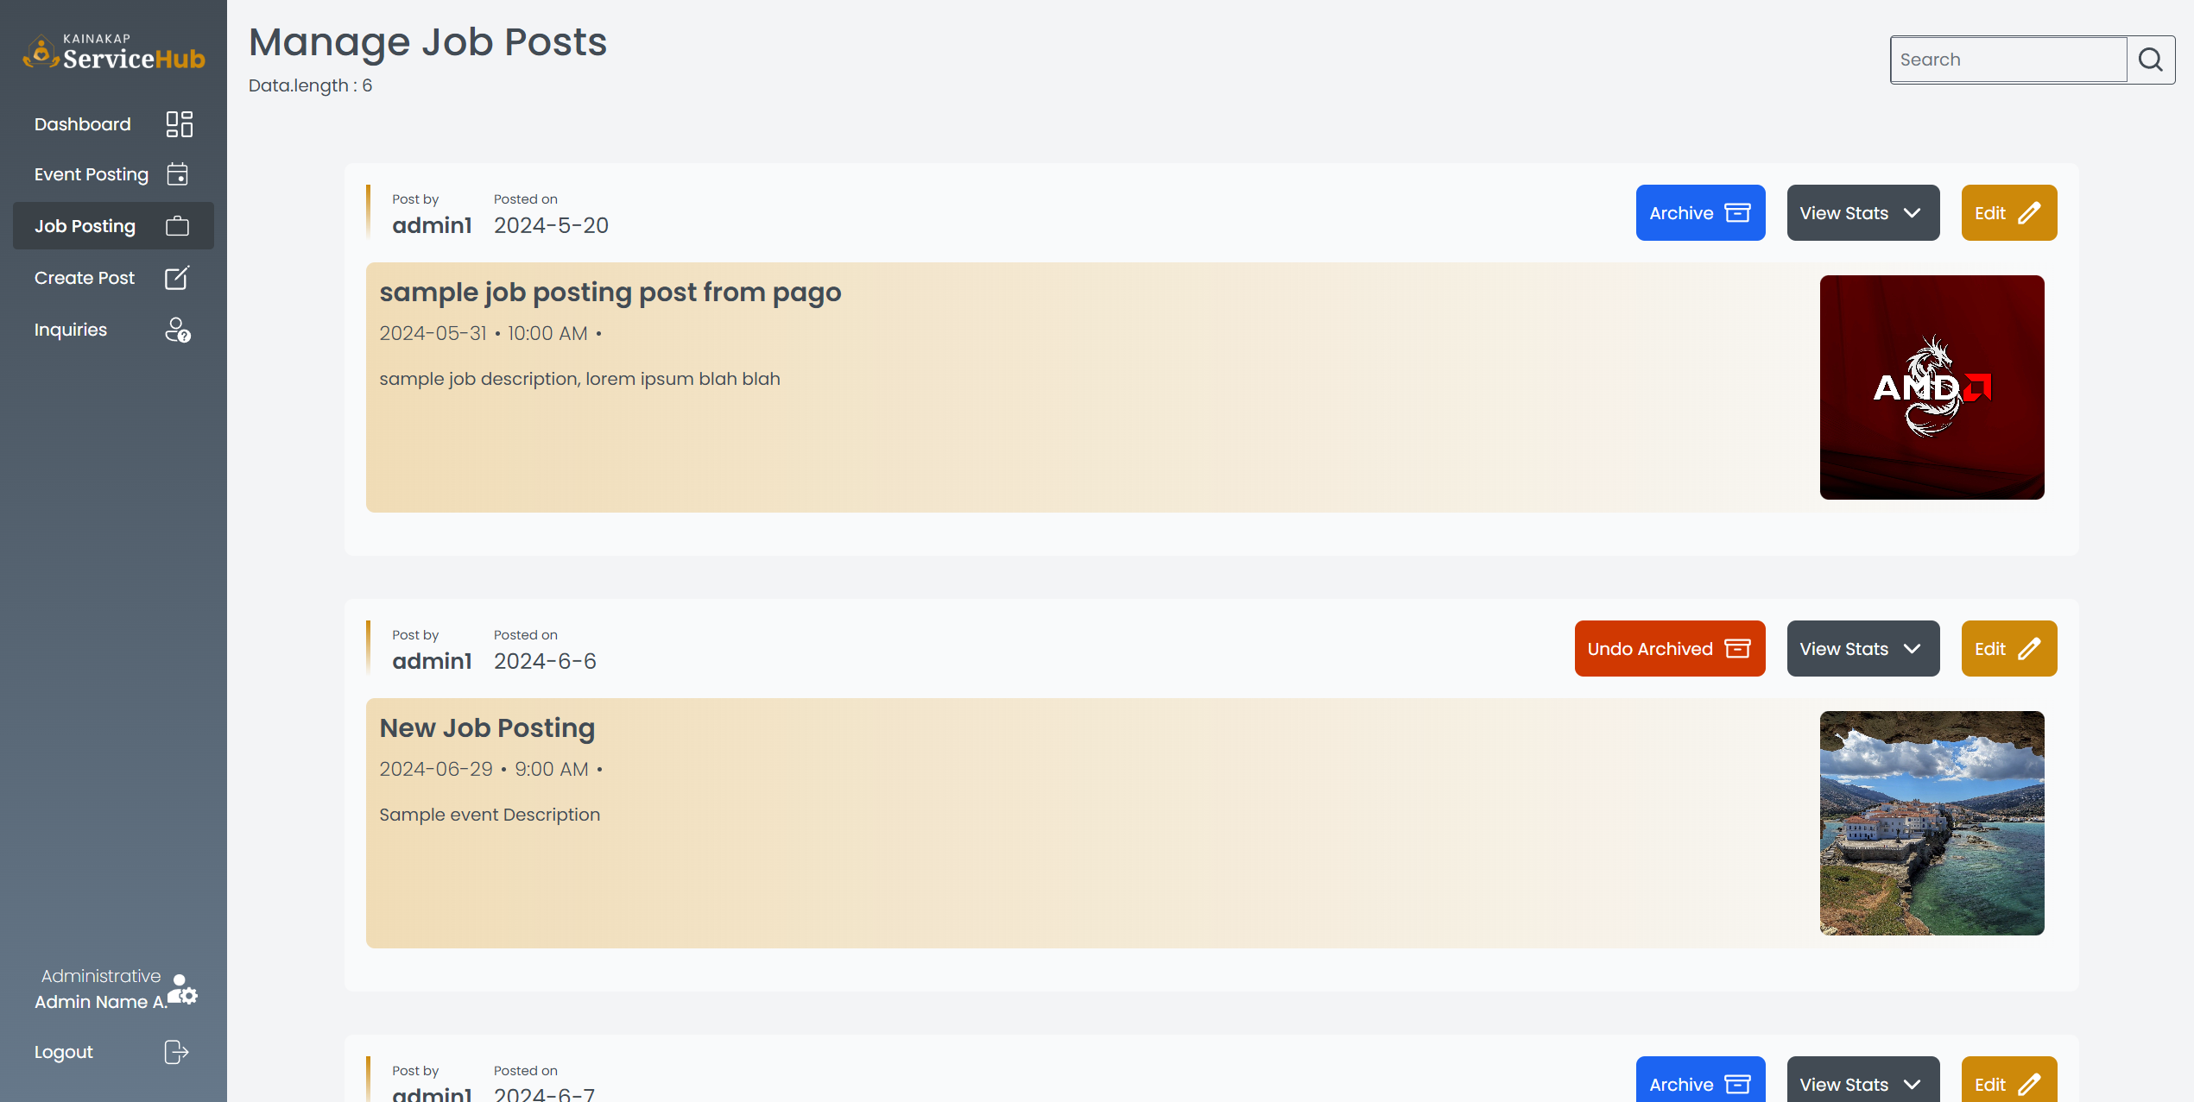

**Figure 4 :** Job Posting

* This page allows admins to press the button archive or undo archive posted jobs, view statistics on who joined the job posting, and edit the posted job.

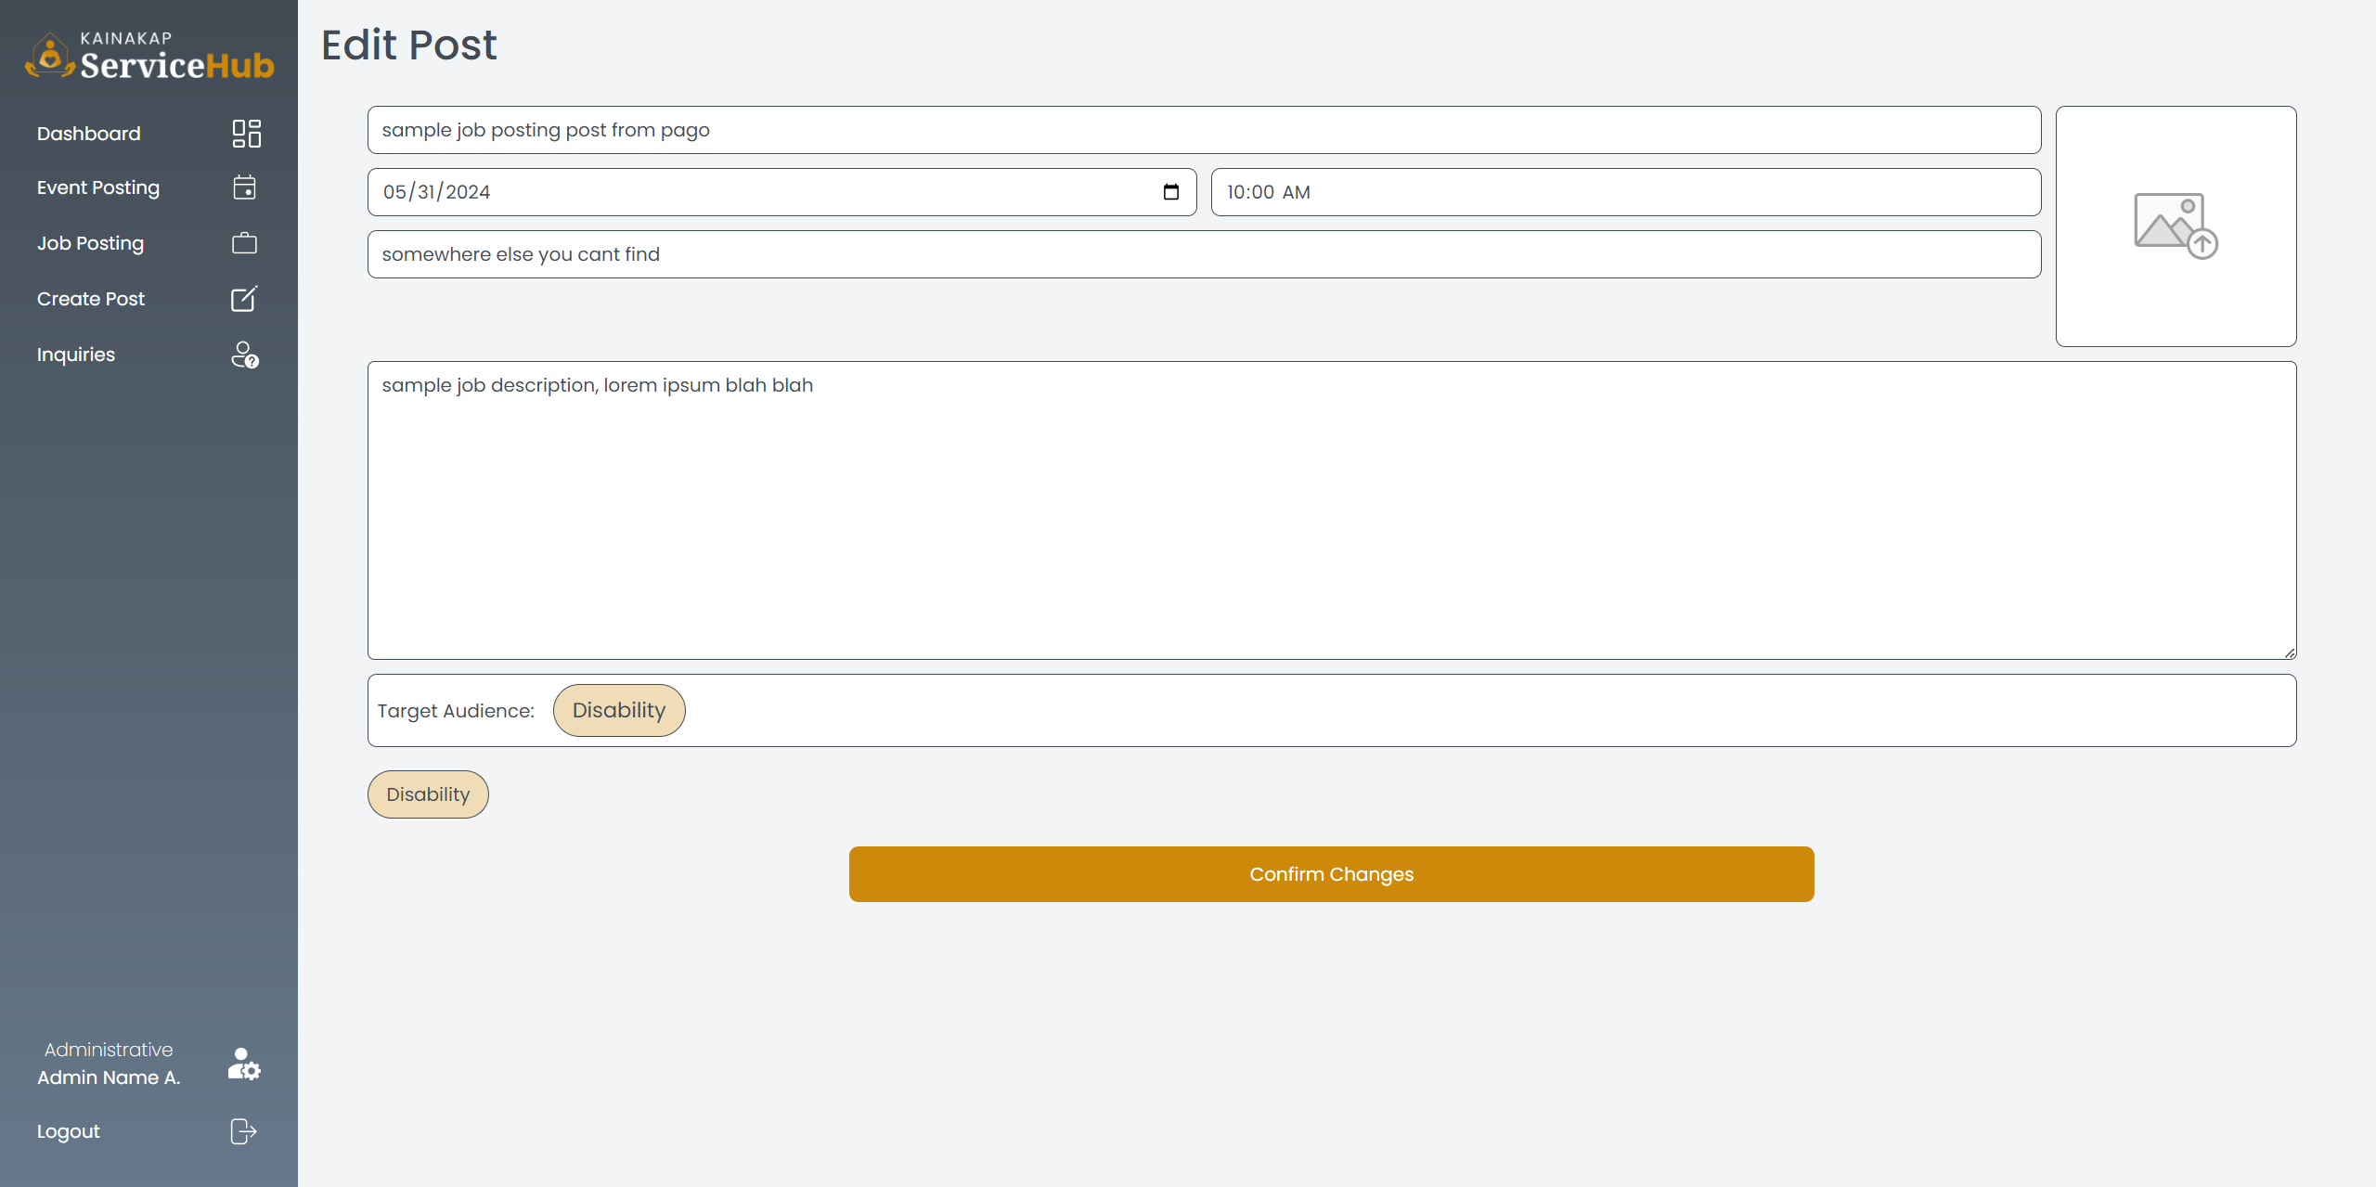

**Figure 4.1 :** Edit Post

* This page allows admins to edit the title of the job, time and date of the job posting, the place where the Job will take place, the context of the Job, and the target user/client eligible to join the job.

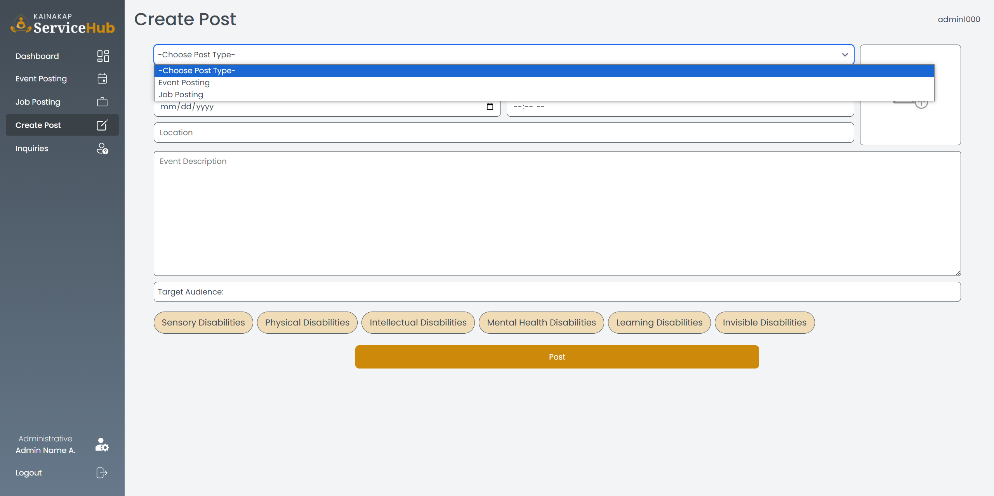

**Figure 5 :** Create Post

* This page allows admins to create a post and choose whether it will be an event posting or a job posting. It includes the title, time and date, place, context, and the target users/clients eligible to join.

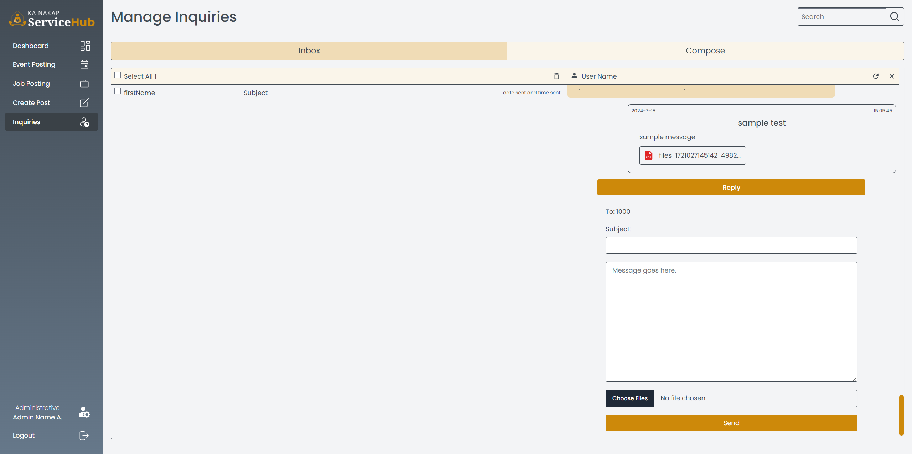

**Figure 6.1 :** Inquiries - Inbox

* The inquiries – Inbox page allows admin to respond to user/client concerns or issues. It includes fields for entering the subject, response message, and a 'Send' button.

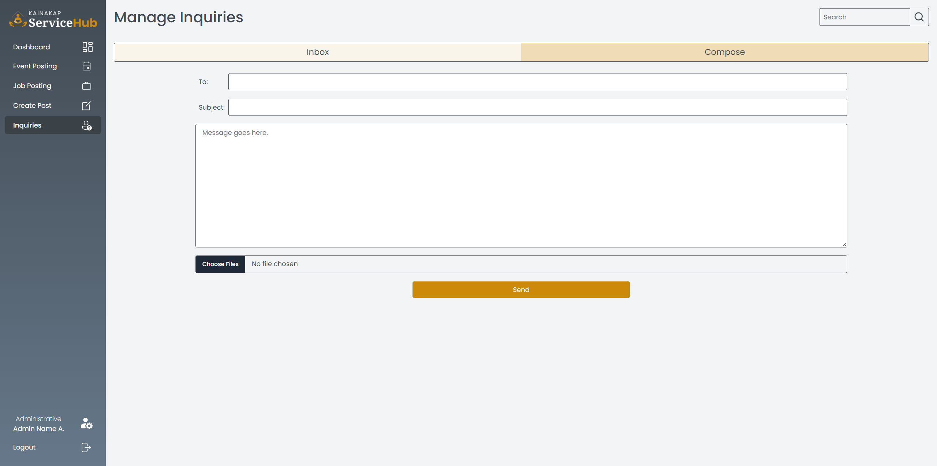

**Figure 6.2 :** Inquiries - Compose

* The Inquiries – Compose page allows admins to create an email, enter a subject, write a message, and choose a file to send to the user/client.